Continuous Linked Settlement (CLS) New Initiatives
Ramesh Ravindran

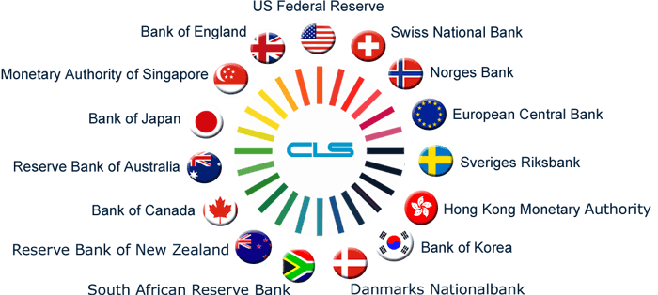



May 4th, 2007

Abstract

This white paper talks about the new initiatives in the continuous linked settlement and the likely benefits of implementing new products on CLS.The last section of the document also describes the areas of opportunities for the IT companies in the new initiatives.

Payment Systems Overview

A basic definition of payment system would be ‘a system which facilitates transfer of money between its users’. And naturally, payment systems act as the lubricant of any economy and have a significant role to play in the overall economic performance of a country.

While they are imperative for any economy, they also expose users to risks and can be a channel to transmit disturbance from one part of the economy or financial sector to the other, leading to destabilization of the entire financial system. Hence most of the critical payment systems are directly controlled by or are under supervision of the central bank of individual countries.

Payments systems are broadly categorized as retail and wholesale payment systems, based on average size of the payment and number of payments exchanged in a day.

Retail payment systems

- These systems are characterized by relatively low value and high volume of transactions. For e.g. the ACH (Automated Clearing House) of US had a volume of about 12000 million transactions in 2004 with an average value per transaction of about 3000 USD.
- Retail payment systems include Checks, ACH (equivalent of Electronic clearing scheme (ECS) in India), Credit Cards, Debit Cards etc.
- Typically used by individuals for their regular payments. Corporates also use these systems for transactions in low value and for non- time critical transactions

Wholesale Payment systems

- These systems are characterized by low volume and high value of transactions. For e.g. Fed wire the RTGS system in US had a volume of 125 million transactions in 2004 with an average value per transaction of about 4 million USD.
- Predominantly used by financial institutions and sometimes by Corporates and individuals for making time-critical high value transactions.
- Typically final fund settlement for ancillary systems like retail payment systems, securities settlement systems, foreign exchange transactions, money market transactions etc. settle through wholesale payment systems.
- Loan disbursement, loan settlement, real estate related transactions are some typical transactions which are settled through wholesale payment systems by individuals and Corporates

CLS Overview

- Continuous Linked Settlement (CLS™) is an industry initiative to eliminate the settlement risk in foreign exchange transactions.

- CLS is a unique process that enables cross border currency transactions to be settled intra-day. As it is a real-time global settlement system, it will significantly reduce the settlement risk caused by delays arising from differences in time zones, legal jurisdictions and operating procedures

- CLS is the market standard for foreign exchange settlement between major banks. As of April 2006 it settled about 240,000 instructions a day in 15 currencies (98% of global foreign exchange trading) and with an average daily value exceeding US$2.5 trillion.

- Prior to introduction of CLS, FX settlement risk (also called as Herstatt Risk) was inherent in the way FX deals are settled, i.e. the risk of one party failing in its obligation

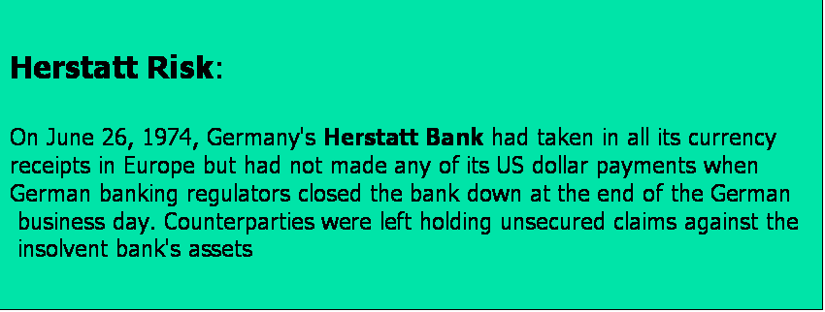

- Pre-CLS mechanism
  - 2 payments for every FX deal
  - The payments are made in different time zones
  - Each deal is settled on a gross basis
  - There is no in-built mechanism to make sure that both parties pay
  - It takes time to detect a problem
  - Banks do business with multiple correspondents
  - The structure is a web, rather than a pyramid

    - The G20 group of banks set up CLS Services in 1997

    - CLS Bank was chartered in New York in 2000.

    - The following 15 currencies are the CLS eligible currencies. Australian Dollar, Canadian Dollar, Danish Crone, Euro, Japanese Yen, Norwegian Crone, Singapore Dollar, Swedish Crone, Swiss Franc, UK Sterling, US Dollar, New Zealand Dollar, Hong Kong Dollar, Korean Won and South African Rand

    - CLS Bank, a new financial institution was set up to reduce the risk involved in settling foreign exchange transactions,

    - According to this set up, the two legs of a transaction are settled simultaneously, and in such a way that one cannot occur without the other.

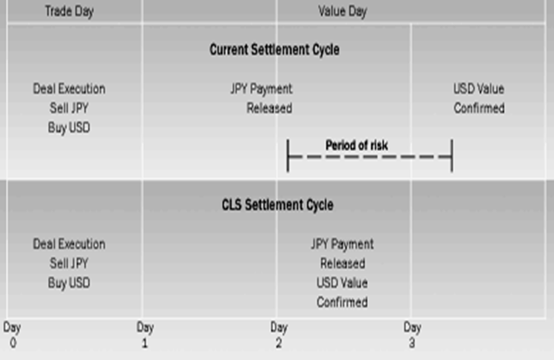

CLS - How does it work?

    - Settlement members hold multicurrency settlement accounts at CLS Bank and can submit directly to CLS Bank the details of transactions, either on their own behalf or for their customers.

    - They are responsible for providing the funding for the amounts to be settled. Settlement members must be CLS shareholders.

    - Settlement members may also offer third-party services whereby they act as principal but submit details of transactions to be settled on behalf of their respective customers.

    - The member accepts these submissions through SWIFT or other mechanisms, replicating the format of an MT300 SWIFT message.

    - Settlement through the CLS system takes place in phases.

- At the beginning of the process, members submit details of transactions to be settled, normally by 00:00 CET on the settlement day.
- Based on all the instructions, CLS Bank then calculates each settlement member’s net total pay-in/payout position for each currency and at 06:30 CET issues a pay-in schedule for each member.

    - Payments to CLS Bank are executed between 07:00 and 12:00 CET.

    - At least part of this time is within the operating hours of most of the RTGS systems used to make payments to and from CLS Bank.

    - In Australia, CLS payments are made during a special evening session of the payment system.

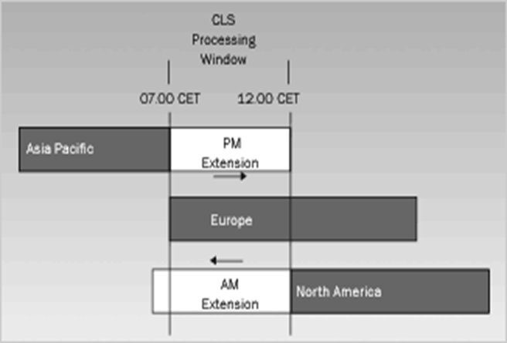

- Each settlement member holds a single multicurrency account, with sub-accounts for each of the seven currencies.

- CLS Bank settles each trade over these accounts by simultaneously crediting the buyer’s account in the currency that is bought and debiting the seller’s account in the currency that is sold.

- Payments between settlement members and CLS Bank are made through the local payment system using the account that, for each currency, CLS Bank holds at the respective central bank.

- In the CLS system, there is a clear distinction between the settlement of transactions and funding, i.e. the transfer of currency between settlement members and CLS Bank.

- Trades are settled between members on a gross basis on CLS Bank’s books. By contrast, member banks have to fund only their net positions on CLS Bank’s central bank accounts.

- Limits are imposed, intra-day on the extent of any negative balance in individual currencies. These limits are specific to each currency

New Initiatives

The current end-to-end trade process from execution to settlement for non-deliverable forwards (NDFs) and FX options is less efficient than it could be and is reported to cost as much as four times that of a typical foreign exchange transaction. Manual processes, lack of standardization including legal documentation and gross settlement of individual cash flows contribute to higher processing and settlement expense. Once settlement of these instruments is implemented in CLS Bank, the related cash flows will be included in CLS Bank’s multilateral netting process, as provided by the existing service and the result will be to minimize net cash funding.

CLS Bank plans to offer a complete end-to-end service from execution to settlement of cash flow positions for NDF transactions and FX option premiums.

Manual intervention will be eliminated from the process for these two instruments. CLS will provide complete all-in-one straight through processing with considerable cost benefits, and an accompanying standard legal framework to govern the process.

CLS Settlement for NDFs

CLS Settlement will create a robust, straight through processing infrastructure for the processing and settlement of NDFs, and brings together several current initiatives in the NDF market. It will use the new SWIFT® standards, supported by EMTA® currency templates. NDFs will be subject to the same risk management framework as the current products eligible for CLS Settlement, allowing benefits to be gained through matching in CLS, and specifically eliminating the current long form confirmation process.

CLS Settlement for FX option premiums

CLS Settlement will involve the matching and confirmation of FX options, including the settlement of the premium. FX option matching within CLS will provide the opportunity to remove external matching processes and create full automation. As CLS will also match the option premium payment, the premium will be included in the CLS settlement process, thereby eliminating the individual payment flows. Firms using CLS Settlement will derive significant automation and cash netting benefits in an environment of increasing volumes and operational risk. CLS will initially offer this service for vanilla options, currently executed using the MT305.

How it works

Non-deliverable forwards (NDF)
On trade date, two parties execute an NDF and instructions relating to the NDF are forwarded to CLS for matching and confirmation of the economic terms. On the valuation (fixing) date, the two parties value the NDF, and the two instructions containing the valuation information are likewise forwarded to CLS for matching. Each original NDF instruction will be updated to include the relevant valuation information.
The NDF settlement amount will be determined based on the difference in the settlement currency (which must be in a CLS eligible currency) specified in the NDF instructions and included for settlement across the books of CLS Bank in the relevant Settlement
Members’ CLS Bank accounts on the settlement date. A similar process is also undertaken when a third party is involved, with the Member managing the submission
of instructions and related payments to CLS as illustrated in Figure 1. CLS provides the Member with real-time information for each of its trades, including those of its third party customers.

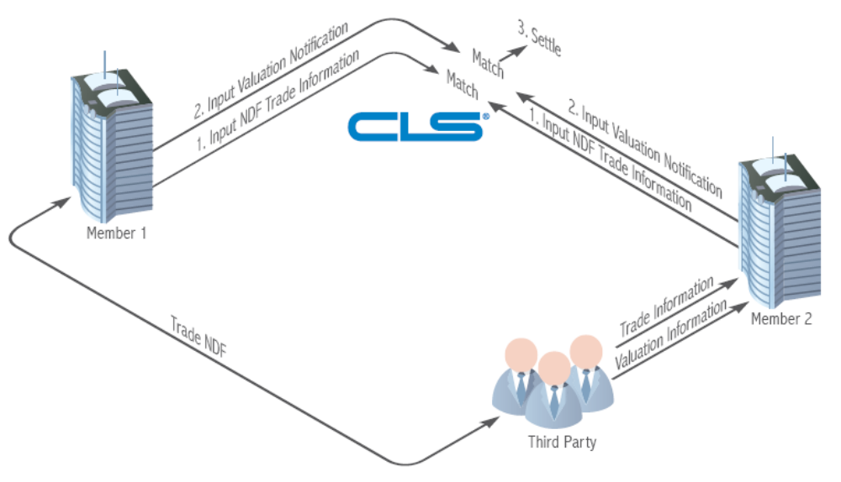
Figure 1

FX Option premiums

On trade date, two parties execute an FX option and payment instructions relating to the FX option are forwarded to CLS for matching. CLS will match and confirm the economic terms of the FX option, including the associated premium (which must be in a CLS eligible currency) and include the option premium payment for settlement across the books of CLS Bank in the relevant Settlement Members’ CLS Bank accounts on the settlement date. Figure 2 demonstrates the transaction flow. CLS provides the Member with real-time information for each of its trades, including those of its third party customers.
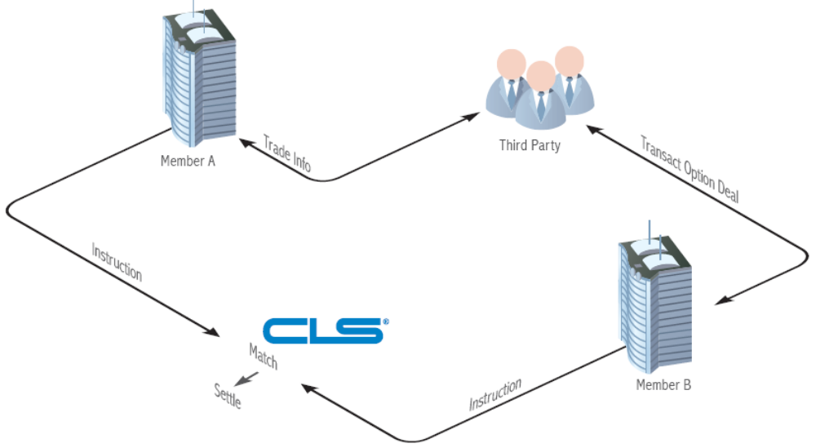

Figure 2

Benefits of Implementing the new products on CLS

By providing a complete end-to-end process from execution to settlement of NDFs and FX option premiums, CLS will deliver the following benefits:

    - Standardization and automation of confirmation and matching allowing for the removal of duplicate flows;
    - Removal of NDF long form confirmation, providing a legal governance structure eliminating the need for bilateral negotiation – a ‘complete package’ for NDFs for the first time
    - Significantly increases the level of market automation for these types of transactions
    - Consolidates cash funding and maximizes the netting benefits of CLS Settlement;
    - Extends CLS Bank’s high standards of resiliency to a broader range of markets;
    - Convergence of FX instruments into a “single pipe” for processing settlements;
    - Reduced operational and payment/settlement risk improves operational risk management under Basel II;
    - Extends the range of services offered to CLS third parties;
    - Offers the opportunity to rationalize nostro networks.

Business Opportunities for IT companies in the CLS Initiatives

    - Build of messages that can be sent by third parties for Trade and Validation Instruction
    - Capability of message building by a Bank’s CLS system
    - Incorporation of client specific considerations with in the Bank’s CLS technical framework
    - Interface Building for the following
- Process workflow from Valuation to Settlement
- Changes to the FX trade initiated from CLS Bank
- Settlement split
- Messages to third parties
- Limits in Bank’s CLS engine and CLS Bank interface

    - Reconciliation between Bank’s CLS engine and CLS Bank’s Interface
    - Modify existing trades/ valuations for NDFs
    - Routing Swift message incorporation
    - Capability of Trade Input system to send confirmations to CLS Bank’s for the new products

Conclusion

CLS settlement will create a robust, straight through processing infrastructure for the processing of NDFs and bring together several current initiatives in the NDF market consolidating the Fx instruments into a "single settlement pipe". This would result in large industry participation owing to demonstrable benefits and growing value proposition

References:

- http://en.wikipedia.org/wiki/Continuous_linked_settlement
- http://www.cls-group.com/
- http://www.riskglossary.com
- http://www.wachovia.com/corp_inst/page/0,,44_45^2125,00.html#327
- http://www.investopedia.com/terms/n/ndf.asp
- http://www.investopedia.com/university/forexmarket/
- http://www.gtnews.com
- http://www-935.ibm.com/services/uk/igs/pdf/ibm_cls.pdf
- http://nacha.org
- http://bis.org

